Some graves appears to be present within clearly demarcated enclosure with a unique set of grave good such as fish skeletons and tortoise shell.

Sarai Nahar : arrow would on the skull : this once again indicates rising competition.

Neolithic ages :

Climate : wamer and weter

Q) Neolithic revolution was no revolution at all. critically analysis.?

Neolithic revolution

1. Subsistence
2. Dwelling
3. Technology
4. Society
5. Trade
6. Religion

Arguments against naolithic age as revolution

1. 3000 years is long time hardly revolutionary.
2. Many of the changes proceeded the neolithic age.
3. Changes affected different regions during different period.

Arguments favors

1. changes over this 3000 year much more radical than previous 30000 year
2. Neolithic ages permanently changes man’s role in the environment he was transform from the food consumer to food producer.
3. Man’s relationship with animals and land was permanently redefine.
4. Neolithic age brought human to the threshold of civilization.

Application of the Neolithic period revolution is still valid although earlier conception is change by the the resent historian

Q) Enumerate the essential characteristic hardpan civilization 200 w

Q) discuss the different the theories to explain the origin of the Harapan civilization? (200W)

Q) Town planning among harappans:

[intro]: Harrapans town planning is one of the most remarkable feature of this civiliasation it did not have the any parallel in the contempered world.

1. Harapan town planning is so advance that it continue even the modern urban planer.
2. Feature :
3. Cities are grid /chess board pattern.

Q) on the basis of archeology, ted the light on the socio economic life of the harappan people.(200 words )

Liga worship of continuous

Q) early vedic age is golden age for women critical anysile (150)

q) shared life upon factor upon for the raising different latter vedic age.(150)

Q) emergence is outcome of specific socio- economic conditions created by second urbanization how did jain philosophy attempt to satifiy the emerging confilt with in the society (200)

Jain:

Jainism is not successful no as other doctrine as other attracting follower primarily because of its emphasis on the extremities on tenant and ascetism’s feather it did not appeal to farmer who constituted the bulk of the population because of it’s strict emphasis of on violence the cultivation involve small animal birds insect , how ever it interesting to note that Jainism obtain heathy following among the new urban classes specially merchant and trader. This was due to the following factor:

1. Jainism created space for this communities for observe the doctrine without complete renouncing there world possession the concept of anusvara(minor voles) Specially crafted to allow this group to follow Jainism without renunciation
2. This community concern loss of resources due to conflict both political and social as such the insistence upon the nonviolence specially attractive to them
3. Another factor which attracted trader to wards Jainism toward approval practice of usury (landing money interest) since usury is important of expansion of commerce and manufacturing it was attractive to communities involve towards this processes.
4. And interesting fact is Jainism began expanding in the earnest when moved out of its original home land (the middle gigantic valley)

The mid gigantic valley was also the birth place of other major doctrine such as Buddhism’s Jainism face intense competition however when it was taken to western and southern Indian from the 4th century onwards it found ample space to grow.

Consequently the bulk of Jain population in India still concentrated to this day Gujrat Maharashtra and Karnataka.

Q) investigate the factor behind low popularity of Jainism as compare to Buddhism’s (150)

Q) disappearance of Buddhism was sudden and unexpected development critically analysis.(200)

1. Rising economic inequlity specially in the urbna envoirnment begger and protitutes
2. Emegance of and affect

Q) discuss the role played by the iron in bring about the second urbanization to what extent is it correct to state that iron played the mode of significant role ? ( 200)

Mahagadhan empire :

Magadha vs

3

Q) Ashoka’s dhamma was a new social and ethical code of conduct which was the outcome of ruler’s benevolence discuss critically anylysis. ( 200)

Content o fdhamma

Dharma : religion philocophy , practices.

Philosophical context : duty -> role .

Ashka’s dhamma :: edicts role of Ashoka

1. Friend
2. Advisor
3. Well sihster
4. Parent

Advisory

Peace happiness content:

Q) highlight the moral and ethical dimensions of ashokas dhamma what can modern society lean from the policy.?

Q) Highlight the strengths and weakness of foreign traveler’s accounts as a sources of ancient Indian history.(200)

Ans : Intro large number of forging travellers due to it imp. As policatl economical religuou center.

* + 1. Greak and roman
       1. Megethes
       2. Throues
       3. Arrian
       4. Prepiplus of trhe erathorean.
    2. Chines
    3. Arab
  1. Strengths of this account
     1. Helps illuminate some dark phases of Indian history for which local literature does not exist. Ex alexander people cover the local history.
     2. Establishing chronology
     3. Historical Information about people , places and elements.
     4. Linguistic analysis.
     5. Comparative analysis
     6. Relative free from bias
  2. Weakness:
     1. They

Modern historian believes that the ujjain symbol. The position of Ujjain is major trading center.

With the growth of the state system the state also became involved in the minting of coin. Probably the morurayes were first ruing group in Indian to issue their own coins. Moirayan punch mark carry their royal embalum that Is peocock.

Historical Significance of coins :

* 1. Material / technological advancement of people.
  2. Cultural development
     1. Art its form style , method.
     2. Religious life gods goddess , mythological creature.
     3. Present / absence oof calligraphy
  3. Chronology
     1. Name of kings and the dates of issuance.
     2. Indo -Greeks 30 kings are known to us through their coins only.
  4. Commorative coins :
     1. Important political developments
  5. Metallic purity of procous metal coins
     1. Level of prosperity.
  6. Number of volume of coins
     1. Volume of trade.
  7. Foreign trading contact
  8. Territorial extent of kings /empire
  9. Coin of Samudra Gupta
     1. Veen player
     2. Vishnu.

Additional details about Mauryan administration:

Nature of state

Monarchy.

He enjoys despotic authority kingship

Heridatory. : rule of premogniture Not strictly follow

\

Role / responsibilities of the state.

Q. maurayans made a remarkable contribution in the field of administration discuss (200)

Intro centralized imeperial system:

Conclustion emerged as model for later empire .

Although huien Tsang claim seem to be exaggeration suta art has a major form of royal art from Ashoka periods onwards.

The tradition of construction of stupa by kings , commoner alive for several centuries as case study history of Sachi stupa is instructive about development of stupa art. It largest ancient stupa in the world. It was originally constructed by Ashoka. And later it renovated and enlarges by kushamitra sunga , Agnimitra shunga. Shimuka (satwaan ) , gauitami putra (satwaan ) several gupta rulers.

Initially only the main structure was made of stone and bricks

It railing , walls and gates made of woods.

Later the hemispherical part (anda) was enlarge roughly twice the original size and entire structure was rebuild in stone.

Sarchi sutpa is one of the best present ancient stupas it has the following feature

Sculpture cover the torana gateways and the outer wall of stupa : jataka stories

Rayal portain and procession

Human’s animals demi-god/ goddess

life like and dynamic sculpture

Highly expressive : full range of emotions

Royal personalities : reserve contentment

With female companions.

Comman people : highly expressive

Animal figure

Dynamic / naturalistic and lifelike

Lion horse , bull and elephants.

Movement capture

Buddha’s images

Not found

Symmboic representation

Mauryan pillars:

1. Ashoka erected numouras piller throughout it empire their important feature :
   1. Chunnar sandstone
   2. 50 -55 ft and 45 -50 tons
   3. All this pillars ware transported over the water and land to their final destination.
   4. This pillars constisted two portain shaft and captical.
   5. Shaft:
      1. It was monolithic
      2. Smooth / highly polish surface
      3. Circular
      4. Taper from bottom to top.
   6. Capital:
      1. Inverted lotus or bell motive .
      2. Circular / rectangular disk know as abacus
      3. Animal figure. Lion bull, elephant , horse.

Are ashoken pillars inspired by / borrowed from perssion art.?

Some colonial historian: both has similarities

1. Capital
2. Animals figure
3. Royal art
4. They appear to have some religious or cultic significance.
5. Inscription

Recent historians :

1. Mourayan may have been aware of perssion pillars but their pillars were the product of indigenous genius dissimilaries

Disimilarites:

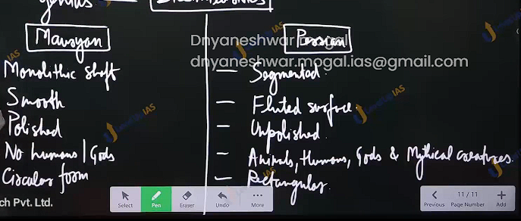

Rock -cut cave

1. Practice of excavating caves began with the maurayes
2. Ashoka and (grandson of Ashoka) Dashrath
3. 7 cave barber and Nagarjuna thills
4. Ajika seat

Structural and stylist feature :

1. On the site of hills
2. Excavated from top to bottom
3. Multistoried and connected with stair
4. Both large walls and interior connected
5. Inner walls -bara but highly polished.

Folk art

Norther black polish ware potter NBPW : multiple varieties of fish extremely fine qulity.

Mauryan pottery :

1. Name Is misleading
2. Ganga vally

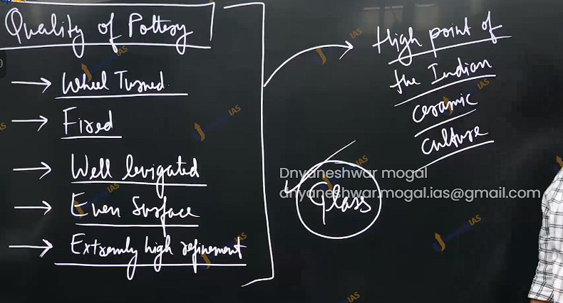

Terracotta sculpture :

1. Probably the most imp. Form of artistic expression by the people
2. tradition of terracotta sculpture was as old as at least the Harapan age
3. however there are significant semantic and stylistic difference between the terracotta sculpture of there of there 2 phases.

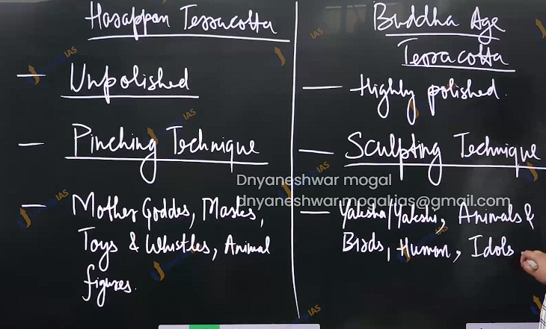

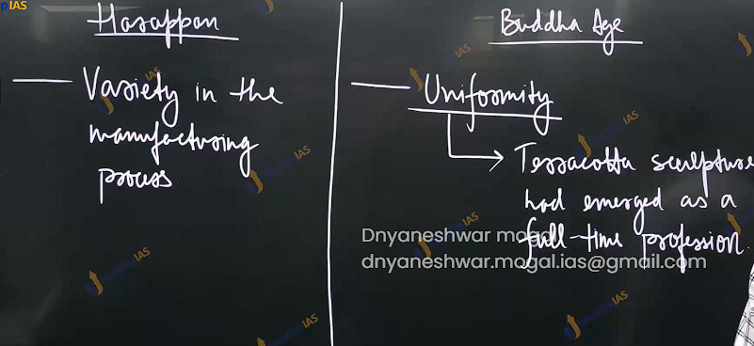

Similarities :

1. Folk art
2. Religious component is predominant
3. Reflect the lives of the common people
4. Reflect the life of common people .
5. Both cases the terracotta of these periods continueied to infrom terracotta art of certain period.
6. Yakshi -didargany(bihar)
   1. It is considered to be the finest example of Mauryan workmanship .
   2. Half clad , highly sensuous female demi god.
   3. Highly polish
   4. Dynamic
   5. Highly ornamented.
   6. Standard of feminine beauty in Acient india.

Q) maurayan made remarkable contribution to the development to art . discuss.200

Q) the terracotta art of the mauryans was the high watermark of this art form discuss and compare Mauryan terracotta with Harappa art 200